Introduction to data related to measurements of temperature profiles in freezing/thawing POM
Note:
- This file is only relevant to temperature profiles in Polyoxymethylene (POM) specimen. Separate metadata file is provided to explain the data for mortars (see the Word file “Introduction to Mortar related data”)
- 3 files belong to the same experiment with POM, and therefore they have the same name.

What are the data about?
The data are temperature measurements obtained with type T thermocouples at various locations in freezing and thawing Polyoxymethylene (POM) specimen exposed to different thermal boundary conditions. The freeze-thaw cycles were applied according to the reference method of CEN/TS 12390-9 (Borås method) [1]. The schematic of the experimental setup and the test specimen dimensions are shown in Figure 1. It also shows the location of temperature sensors and different parts of the prepared test specimen in Figure 1 (a). The temperature control unit (shown as the cooling unit in Figure 1 (a)) applied freeze-thaw cycles on the test surface of the specimen, and the climate cabinet controlled the surrounding air temperature of the placed setups. The temperature at various depths was recorded at 10s intervals. However, the temperature of the test liquid was recorded at 60s intervals using a type T thermocouple that was hanging in the test liquid.

What shows the file name?
A typical file name or specimen ID looks like POM-0s-3mm-20°C. Each part of the name describes certain attributes, as:
$$\underset{\begin{aligned}It is the POM \\ specimen (not mortar) \\ \end{aligned}}{\underbrace{POM}}-\underset{\begin{aligned}Salt concentration is 0\% \\ in the test liquid\end{aligned}}{\underbrace{0s}}-\underset{\begin{aligned}Thickness of test liquid \\ is 3 mm,\end{aligned}}{\underbrace{3mm}}-\underset{\begin{aligned}Surrounding temperature \\ is 20°C\end{aligned}}{\underbrace{20°C}}$$

What are the 3 files appearing with the same name starting with “POM”?
3 files belong to one experiment, and therefore they have the same name. The details of these files are as follows:
Excel spreadsheet (.xlsx) | Contains sensor calibration, recorded raw data, and the corrected data that is corrected using the calibration.
Unicode Origin Graph file (.opju) | Contains corrected data + Graphs  Corrected data are copied from the Excel spreadsheet to this file. Graphs are drawn for every 24 hours where the start and end times are taken from the start of the experiment (time zero “0”). Moreover, the additional graphs providing a zoomed view of the freezing peak that occurs when test liquid transforms into ice are also drawn.
Comma separated values file (.csv) | This file contains corrected data in csv format exported from the Unicode Origin Graph file.

Which file shall be used?
If the reader is interested in corrected/calibrated and finalized data, the reader shall use either Comma separated values file or Unicode Origin Graph file. However, if reader wants to see originally logged data and processing of the data, the Excel spreadsheet file shall be consulted. Since graphs are also drawn in Unicode Origin Graph file, it contains the optimum information. However, a reader may not have access to OriginPro, and therefore Comma separated values file is provided for ease of use. The Comma separated values file and Unicode Origin Graph file contain the same data.

Which decimal separator is used?
The files use point ”.” as the decimal separator.

How was the data processed?
The data were initially recorded in the form of csv files. The data were then copied and pasted to the Excel spreadsheet file, where it were corrected using calibration. The original logged files were in several parts, and therefore the data were combined in the Excel spreadsheet for ease of the reader. Each sensor was calibrated, and therefore measurements obtained with each sensor were corrected using its calibration.

The data were recorded with the original date and time. The time column was also changed to start from time zero “0”. The corrected and finalized data was copied to the Unicode Origin Graph file. The data were then exported in Comma separated values file. See “Detailed description of the columns in Excel spreadsheet” provided in the following pages to infer about which column corresponds to which temperature sensing location.

What Comma separated values file and Unicode Origin Graph files contain?
Each file contains several columns corresponding to time and temperature measurements at different locations. A typical Comma separated values file or Unicode Origin Graph file contains the following columns:
Time (h) | Surface | 5mm | 10mm | 15mm | 20mm | 45mm | Time (h) | Test Liquid
Time in hours starting from zero (from start time of experiment) for Surface – 45mm sensors | Temperatures measured in °C at the Test Surface, 5 mm, 10 mm, 15 mm, 20 mm, and 45 mm below the test surface (see Figure 1 (a)). |  |  |  |  |  | Time in hours starting from zero (from start time of experiment)  for Test liquid sensor | Temperature sensor hanging in the test liquid and measuring its temperature in °C

Special information: The Test liquid sensor was the feedback sensor. This sensor showed different behavior in different calibrations. Therefore, its accuracy was questionable, and calibration was not used to correct the data measured with this sensor. Therefore, it is suggested that conclusions shall not be based on measurements obtained with this sensor. The Surface sensor was located on the test surface and provided reliable results and shall be used instead of Test liquid sensor to perform analysis. See “Detailed description of the columns in Excel spreadsheet” provided in the following pages to infer about which column corresponds to which temperature sensing location.

What contains the Excel spreadsheet?
A typical Excel spreadsheet has several rows and columns. Their details are as follows
(Row range)×(Column range) | Description
(1-10) × (A-H) | It is the calibration data. Column A shows set point in calibration, B shows the temperature of the reference sensor (calibrator’s sensor), and columns C-H show the temperature measured by different sensors.
(1-10) x (M-W) | These rows and columns provide the temperature difference between the reference sensor and other temperature sensors at different set points.  Note: Calibration is slightly different at different set points. For example, the temperature difference between the reference sensor and a particular sensor at 20°C may appear different than at 0°C. Therefore, the obtained differences at all set points are used in calibrating the data.
(23-Last) × (A-AA) | It is the recorded raw data, where the columns A-AA show the raw data for all temperature sensors except the Test liquid sensor. Further details are provided in the next table under “Detailed description of the columns in Excel spreadsheet”.
(23-Last) × (AB-AM) | It is also the recorded raw data, where the columns AB-AM show the recorded raw data related to the temperature control unit (Peltier element) and the Test liquid sensor. Further details are provided in the next table under “Detailed description of the columns in Excel spreadsheet”.
(23-Last) × (AP-BO) | The calibration is applied here to correct the data. These cells take value from raw data and use the calibration and the temperature differences to correct the data. A formula is used to apply correction using linear interpolation, according to different temperature ranges (e.g. 20 to 15, 0 to -5). It means that the error at 20 and 15 are distributed from 20 to 15. Moreover, the start time is systematically changed to start from zero.  The final used columns for analysis and drawing graphs are (AR to BC). Further details are provided in the next table under “Detailed description of the columns in Excel spreadsheet”.
(23-Last) × (BS-BW) | These columns provide time and temperature measurements for Test liquid sensor. The data was processed in these columns to obtain temperature values corresponding to Time in hours. Calibration was not applied to this data as calibration was not possible for Test liquid sensor. Further details are provided in the next table under “Detailed description of the columns in Excel spreadsheet”.

Detailed description of the columns in Excel spreadsheet
Description of the region (23-Last) × (A-AA) that deals with the temperature measurements of all sensors except the Test liquid sensor is provided below. The columns and description of each column is as follows:
Place | Date | Time | s1 | Unit | s2 | Unit | s3 | Unit | s4 | Unit | s5 | Unit | s6 | Unit | s7 | Unit | s8 | Unit | s9 | Unit | s10 | Unit | s11 | Unit | s12 | Unit
Number of data point (1 point in 10s). It can start other than zero | Test start date | Test start time | Recorded Raw temperature at 5 mm below test surface | *1 | Recorded Raw temperature at 20 mm below test surface | *1 | Recorded Raw temperature at 15 mm below test surface | *1 | Recorded Raw temperature at 10 mm below test surface | *1 | Recorded Raw temperature at 45 mm below test surface | *1 | Recorded Raw temperature at the test Surface | *1 | Not concerned columns
*1: the unit column shows that the temperature is measured in °C. All temperatures were measured in °C

Description of the region (23-Last) × (AB-AM) that deals with the temperature measurements of the Test liquid sensor and additional measurements of the temperature control unit (Peltier element) is provided below. The columns and description of each column is as follows:
Time and date | T (°C) | Tpeltier (°C) | Pheating (W) | Pcooling (W) | Runtime (sec) | Hour | Tset (°C) | Pheatmax (W) | Pcoolmax (W) | Tstart (°C) | Tend (°C)
Recorded Raw Time and date from the start of the Freeze-thaw test | Recorded Raw temperature of the test liquid measured by Test liquid sensor | Temperature difference between the hot side and the cold side of Peltier element | Power consumption of temperature control unit (Peltier element) in heating | Power consumption of temperature control unit (Peltier element) in cooling | Time from the start of test in seconds | Time from the start of test in hours (0-24) | Set point temperature for the Test liquid sensor | Maximum allowed power in heating that Peltier element can use | Maximum allowed power in cooling that Peltier element can use | Not concerned

Description of the region (23-Last) × (AP-BO) that deals with the corrected time and temperature values of all sensors except the Test liquid sensor is provided below. The columns and description of each column is as follows:
Date | Time(h) | . Time(h) | s1 | s2 | s3 | s4 | s5 | s6 | s7 | s8 | s9 | s10 | s11 | s12
Test start date | Time in hours starting from start of test | Time in hours starting from start of test | Corrected temperature at 5 mm below test surface | Corrected temperature at 20 mm below test surface | Corrected temperature at 15 mm below test surface | Corrected temperature at 10 mm below test surface | Corrected temperature at 45 mm below test surface | Corrected temperature at the test Surface | Not concerned columns

Description of the region (23-Last) × (BS-BW) that deals with the corrected time and temperature values of the Test liquid sensor is provided below. The columns and description of each column is as follows:
Time | Temp |  | Time (h) | Temp (°C)
Raw Time for Test liquid sensor in Date and time format | Temperature measured by Test liquid sensor | Raw Time for Test liquid sensor in time format HH:MM:SS | Used Time in hours from the start of test | Used Temperature measured by Test liquid sensor

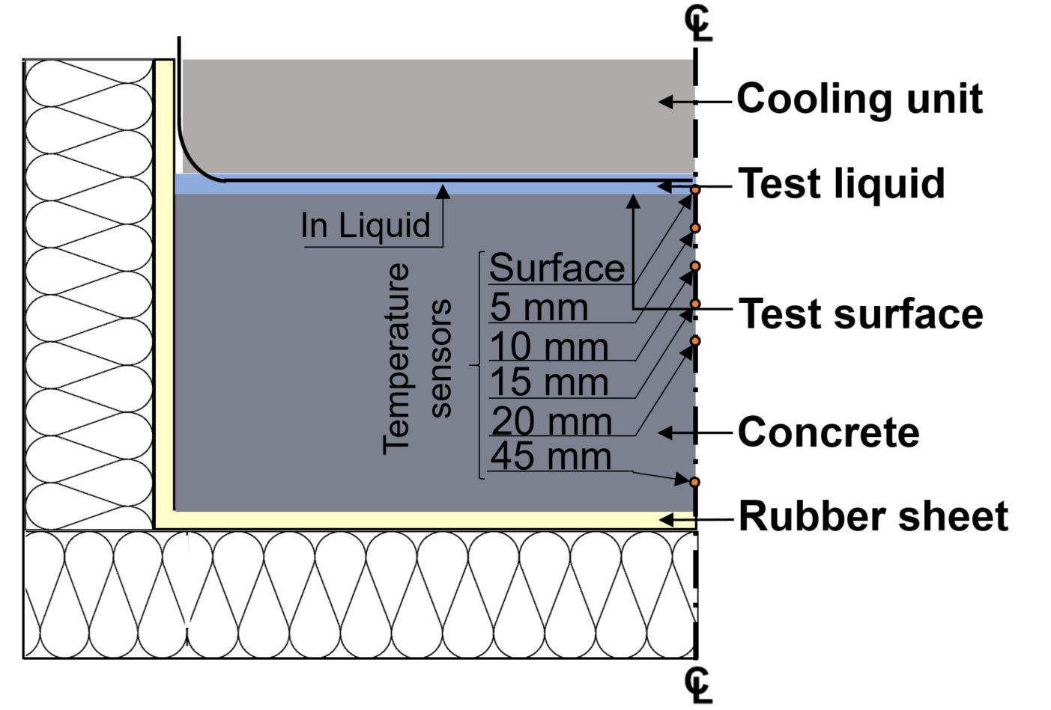  POM | 50  25  78  Test Surface
(a) | (b)
Figure 1: (a) Cross section of prepared specimen and test setup with temperature sensor locations measured from test surface, (b) Dimensions of the test specimen (all measurements are in mm)

References
[1] DS/CEN/TS 12390-9:2016, Testing hardened concrete – Part 9 : Freeze-thaw resistance with de-icing salts – Scaling, (2016).

